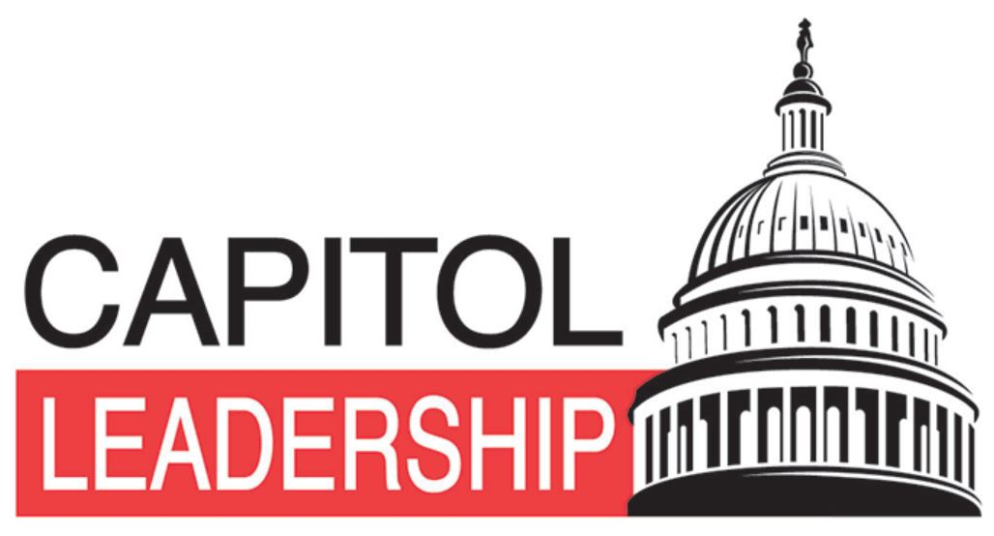
SOUTH DAKOTA FCCLA
CAPITOL LEADERSHIP
October 10-11, 2022
STIPEND APPLICATION
The purpose of this stipend application is to select two, South Dakota FCCLA members interested in expanding their leadership and advocacy skills by actively participating in Capitol Leadership held in Washington, D.C. on October 10-11, 2022. Each stipend will be valued at $150.00. Check this link out for more information on Capitol Leadership -
http://fcclainc.org/meetings/capitol-leadership.php.

Complete the statement of interest in attending the 2022 National FCCLA Capitol Leadership training in
Washington, D.C. and return to SD FCCLA via e-mail by sending application to kris.brockhoft@sdstate.edu
by 5:00 P.M. on September 19, 2022. Applicants selected to receive $150 stipend to defray travel/registration expenses will be contacted on September 26, 2022. Online (regular rate) registration deadline is September 14, 2022.

As a potential Capitol Leadership delegate from South Dakota, write a brief statement about why you would like to attend Capitol Leadership and how you would make use of this experience. Include a list your leadership qualifications (organizations and activities in which you participate in school and the community). Submit your statement/leadership qualifications on the back of this form or in a separate typed document.

Name Adviser

Grade Level_________ Number of Years in FCCLA_________ Male________ Female

List Family and Consumer Sciences Courses Taken:
______________________________________________

Name of Chapter/School

School Address

Applicant E-Mail Address

Adviser E-Mail Address

Adviser Phone Number: School Cell

Applicant Phone Number: Home Cell

My son/daughter has my permission to attend 2022 Capitol Leadership Conference in Washington, D.C. The applicant is vying for a $150 stipend to put towards member’s cost of attending the 2022 Capitol Leadership training. All registration and travel expenses will be the responsibility of the member/attendee.

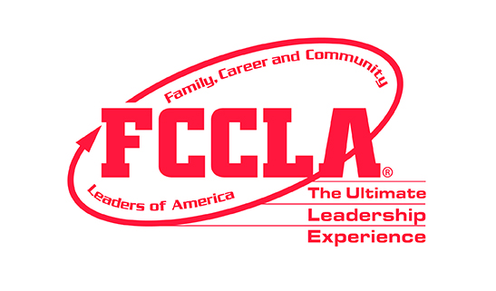
Parent/Guardian Signature Date

Recipients will receive stipend upon successful completion of Capitol Leadership training.
(Please use the back of this application or attach a separate typed sheet of your leadership qualifications and statement.)

