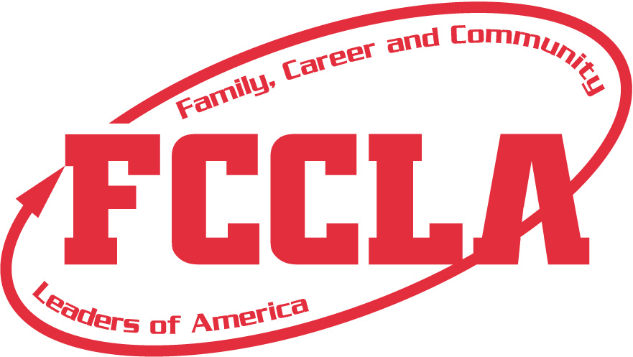
MEMBER CODE OF CONDUCT/
PHOTOGRAPHY CONSENT FORM**
2024-2025 South Dakota FCCLA Region/State/National Conferences

Chapter Name: __________________________ Member Name: ___________________________________________
(Please Print)
This form must be read and signed by the student, parent, adviser/school representative and administrator.
- Behavior at all times should reflect a positive, professional image. Delegates will refrain from using inappropriate or profane language when
attending conference activities, refrain from verbal, physical, or sexual harassment, hazing, or name calling, refrain from the use or possession
of alcoholic beverages, narcotics, tobacco products, or weapons in any form. Possession is defined as having in one’s belongings such as a purse
or luggage, in one’s hotel/motel room, or having knowledge that alcoholic beverages, narcotics, tobacco products, or weapons are in one’s hotel/motel room or in another person’s possession at any time. Delegates will be required to wear facemasks if required by designated meeting site to prevent the spread of COVID-19. Delegates are representatives of their school district and must comply with the policies regarding student conduct.
- Delegate Dress Code: If not wearing the FCCLA official uniform (red blazer, black pants/skirt/sheath dress), the mandatory dress code should be worn: red, black, or white polo or dress shirt (long or short sleeves), black dress slacks/pants/capris, black skirts or sheath dress – no shorter than 2 inches above the knee, dress shoes (preferably black). (Jeans, t-shirts, shorts, yoga pants, workout pants, leggings, or athletic wear are NOT acceptable.) Thank you for your cooperation and support in putting forth a positive image of FCCLA. Delegates appropriately dressed will be allowed to participate. Delegates must wear identification badges at all times. Official red blazer/uniform is required dress at the National Leadership Conference.
3. Delegates are required to attend all sessions and activities assigned, including workshops, exhibits, Competitive Events, etc. for which they
are registered unless engaged in a specific assignment scheduled at the same time. Students shall keep their adviser/adult chaperones
informed of their activities and whereabouts at all times. No delegate shall leave the conference premises, including their assigned hotel,
hotels in which conference events are taking place, and the convention center, unless permission is received from their chapter adviser, and
the student is in the company of another adult upon departure. Delegates should be prompt and prepared for all activities.
4. Report accident/injuries/illnesses to the adult chaperone/adviser & state adviser immediately. An original, signed copy of Code of Conduct &
Medical Release form will be retained by the school, one by chapter adviser, and one will be submitted at conference registration by the adviser.
5. Delegates will stay in their assigned hotel room shared with other members from their school, knowing the risk of the inability of 100% use of
masks and distancing within lodging rooms. Curfew will be enforced. Delegates are required to be in their assigned hotel room during curfew
hours. Quiet hours will be observed after curfew. Delegates are expected to be respectful of other hotel guests.
7. Delegates are not allowed in the sleeping rooms of the opposite gender, except when an adviser/adult chaperone is present.
8. There shall be no defacing of public or private property. The individual or chapter responsible will be pay for damage to any property or
furnishing in the hotel rooms, convention center, or any other area.
9. The enforcement of the Code of Conduct is the responsibility of the adviser/school representative. The adviser/school representative will call
the school administrator for direction. For violation of any of the above, parents will be contacted, and student(s) will be sent home immediately at their own expense. The adviser/school representative will submit this Code of Conduct to the state adviser prior to attending state level events.
10. Delegates who ignore or violate any of the rules will be subject to disciplinary action, including, but not limited to, disqualification from competitive event
involvement and expulsion from FCCCLA.

I have read, understand and agree to abide by the FCCLA Code of Conduct in its entirety. We also agree that school officials, FCCLA chapter
advisers, FCCLA state association staff, or FCCLA national staff members have the right to send home from the activity at our expense,
provided that he/she has violated the Code of Conduct and/or his/her conduct has become a detriment to the conference experience.
I hereby give SD Family, Career and Community Leaders of America (FCCLA) the absolute right and permission to photograph me. I hereby grant to SD FCCLA all rights to reproduce and disseminate such photographs and images, in whole or in part, or altered in character or form, that will be used by the
SD FCCLA in conjunction with presentations, programs, and publications.

I further grant SD FCCLA all rights to make further reproductions of such pictures and images through any media, for educational purposes, art,
entertainment, advertising of, and internal use for other lawful purposes. I also grant to SD FCCLA the right to copyright such pictures and images in
its own name or to publish, to market, and to assign without compensation or report to me.

I hereby waive the rights or interests that I may have in the pictures or images, including my rights to inspect and/or approve the finished photographs
and images or the use of which it may be applied so long as its use shall be lawful.

I expressly release SD FCCLA, their agents, employees, licensees and assigns from and against any and all claims which I have or may have for invasion
of privacy, defamation or any other case of action arising out of the production, distribution, publication, and exhibition of the photographs and images.

___________________________________________________________ __________________________________________________________
Student Signature Date
___________________________________________________________ __________________________________________________________
Parent/Guardian Signature Parent/Guardian Telephone Number
___________________________________________________________ __________________________________________________________
Adviser/School Representative Signature School Name and District Number
___________________________________________________________ __________________________________________________________
School Administrator Signature Administrator Phone Number
**Submit original, signed, hard copy of this form along with completed registration form, original, signed copy of student permission/medical release form, &
payment for first state level meeting held; document will be kept on file at state office for subsequent meetings for rest of school year.**

