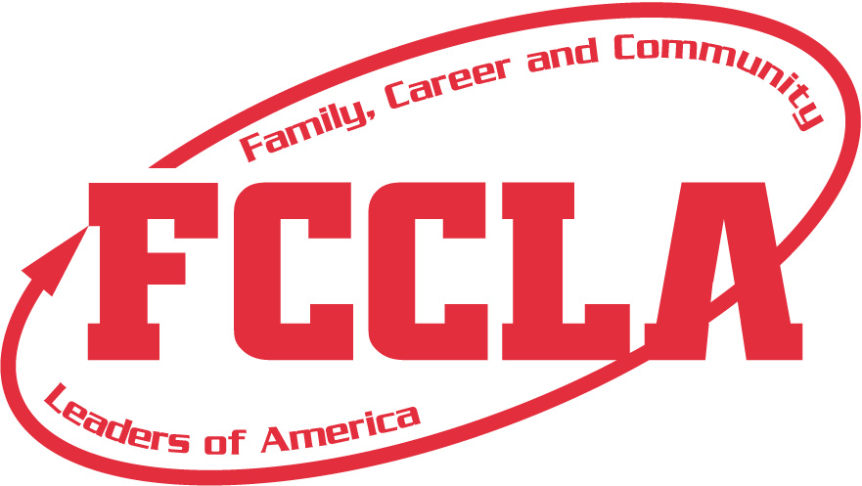
2024-2025 South Dakota FCCLA Region/State/National Conferences
MEMBER CODE OF CONDUCT/PHOTOGRAPHY CONSENT FORM**
Chapter Name ________________________________ Member Name: _______________________________________________
(Please Print)
This form must be read and signed by the student, parent, adviser/school representative and administrator.
- Behavior at all times should reflect a positive, professional image. Delegates will refrain from using inappropriate or profane language when attending conference activities, refrain from verbal, physical, or sexual harassment, hazing, or name calling, refrain from the use or possession of alcoholic beverages, narcotics, tobacco products, or weapons in any form. Possession is defined as having in one’s belongings such as a purse or luggage, in one’s hotel/motel room, or having knowledge that alcoholic beverages, narcotics, tobacco products, or weapons are in one’s hotel/motel room or in another person’s possession at any time. Delegates will be required to wear facemasks if required by designated meeting site to prevent the spread of COVID-19. Delegates are representatives of their school district and must comply with the policies regarding student conduct.
- Delegate Dress Code: If not wearing the FCCLA official uniform (red blazer, black pants/skirt/sheath dress), the mandatory dress code should be worn: red, black, or white polo or dress shirt (long or short sleeves), black dress slacks/pants/capris, black skirts or sheath dress – no shorter than 2 inches above the knee, dress shoes (preferably black). (Jeans, t-shirts, shorts, yoga pants, workout pants, leggings, or athletic wear are NOT acceptable.) Thank you for your cooperation and support in putting forth a positive image of FCCLA. Delegates appropriately dressed will be allowed to participate. Delegates must wear identification badges at all times. Official red blazer/uniform is required dress at the National Leadership Conference.
3. Delegates are required to attend all sessions and activities assigned, including workshops, exhibits, Competitive Events, etc. for which they are registered unless engaged in a specific assignment scheduled at the same time. Students shall keep their adviser/ adult chaperones informed of their activities and whereabouts at all times. No delegate shall leave the conference premises, including their assigned hotel, hotels in which conference events are taking place, and the convention center, unless permission is received from their chapter adviser, and the student is in the company of another adult upon departure. Delegates should be prompt and prepared for all activities.
4. Report accident/injuries/illnesses to the adult chaperone/adviser & state adviser immediately. An original, signed copy of Code of Conduct & Medical Release form will be retained by the school, one by chapter adviser, and one will be submitted at conference registration by the adviser.
5. Delegates will stay in assigned hotel room shared with members from their school, knowing the risk of the inability of 100% use of or distancing within lodging rooms. Curfew will be enforced. Delegates are required to be in their assigned hotel room during curfew hours. Quiet hours will be observed after curfew. Delegates are expected to be respectful of other hotel guests.
7. Delegates are not allowed in the sleeping rooms of the opposite gender, except when an adviser/adult chaperone is present.
8. There shall be no defacing of public or private property. The individual or chapter responsible will be pay for damage to any property or furnishing in the hotel rooms, convention center, or any other area.
9. The enforcement of the Code of Conduct is the responsibility of the adviser/school representative. The adviser/school representative will call the school administrator for direction. For violation of any of the above, parents will be contacted, and student(s) will be sent home immediately at their own expense. The adviser/school representative will submit this Code of Conduct to the state adviser prior to attending state level events.
10. Delegates who ignore or violate any of the rules will be subject to disciplinary action, including, but not limited to, disqualification from competitive event involvement and expulsion from FCCCLA.

I have read, understand and agree to abide by the FCCLA Code of Conduct in its entirety. We also agree that school officials, FCCLA chapter advisers, FCCLA state association staff, or FCCLA national staff members have the right to send home from the activity at our expense, provided that he/she has violated the Code of Conduct and/or his/her conduct has become a detriment to the conference experience.
I hereby give SD Family, Career and Community Leaders of America (FCCLA) the absolute right and permission to photograph me. I hereby grant to SD FCCLA all rights to reproduce and disseminate such photographs and images, in whole or in part, or altered in character or form, that will be used by the SD FCCLA in conjunction with presentations, programs, and publications.

I further grant SD FCCLA all rights to make further reproductions of such pictures and images through any media, for educational purposes, art, entertainment, advertising of, and internal use for other lawful purposes. I also grant to SD FCCLA the right to copyright such pictures and images in its own name or to publish, to market, and to assign without compensation or report to me.

I hereby waive the rights or interests that I may have in the pictures or images, including my rights to inspect and/or approve the finished photographs and images or the use of which it may be applied so long as its use shall be lawful.

I expressly release SD FCCLA, their agents, employees, licensees and assigns from and against any and all claims which I have or may have for invasion of privacy, defamation or any other case of action arising out of the production, distribution, publication, and exhibition of the photographs and images.

___________________________________________________________ __________________________________________________________
Student Signature Date
___________________________________________________________ __________________________________________________________
Parent/Guardian Signature Parent/Guardian Telephone Number
___________________________________________________________ __________________________________________________________
Adviser/School Representative Signature School Name and District Number
___________________________________________________________ __________________________________________________________
School Administrator Signature Administrator Phone Number
**Submit original, signed, hard copy of this form along with completed registration form, original, signed copy of student permission/medical release form,
& payment for first state level meeting held; document will be kept on file at state office for subsequent meetings for rest of school year.**

SOUTH DAKOTA FCCLA
2024-2025 Student Medical Release Form

Name of Student __________________________________________ Date of Birth __________________ Cell Phone____________________
Home Address ____________________________________________ Food Allergies/Physical Restrictions ______________________________
Name of School______________________________ Adviser _____________________ Adviser Cell Phone _______________________________
Name of Parent(s)_____________________________________________Parent Cell Phone(s) __________________________________________
Medical Information
Health Insurance Company Name __________________________________________ Policy Number ___________________________________
Policy Holder’s Name _______________________ Known allergies (drug or natural) _____________________ Date last tetanus shot ___________

Medication being taken ___________________________ History of heart condition/diabetes/asthma/epilepsy/rheumatic fever _________________
Other conditions _________________________________ Family Doctor _______________________________ Phone _______________________
I, the parent/guardian do hereby grant permission and certify that the above named student has my permission to attend the 2024-2025 local, region, and state conferences hosted by South Dakota FCCLA and national conferences hosted by the National Association. It is understood that members must adhere to the guidelines and protocol as set forth by each individual FCCLA event.
Liability Release
I hereby hold harmless and waive and release any liability claims or causes of action against National FCCLA, its directors, officers, employees, FCCLA school officials and chapter advisers, FCCLA state association and staff, and members in attendance, which my son/daughter or I may now or hereafter have arising in connection with my child’s travel, attendance, and participation, including, without limitation, claims for personal injury, bodily harm, illness, and disease (including without limitation, risk of death), and pertaining to causes including the current, potentially lethal COVID-19 virus for which there is as yet no known or available cure.
In the event of an emergency, I do voluntarily authorize medical services to be administered and/or obtained for the above named student as deemed necessary in medical judgment and in accordance with the above confidential information. I authorize the chapter adviser or other chaperoning adult to secure the services of a physician or hospital in the event of my son/daughter’s accident or illness, and willingly incur and will provide payment for the costs. I understand that, when necessary, in the event of an emergent illness or injury, my child will be transported to a local medical facility at the choice of the emergency medical professionals who respond.
I also understand that should my son/daughter become ill with COVID-19, I must travel to meeting site to care for my teenager within 24 hours’ notice. Additionally, my son/daughter will show no signs of COVID-19 in the hours/days prior to traveling to Fall Leadership Conference-Oct. 6-7, 2024; Region Meeting, State Leadership Conference-April 27-29,2025; or National Leadership Conference-July 5-9, 2025 in Orlando, FL.

I understand that participation in workshops/activities that may involve physical activity presents certain risks and hazards, including, but not limited to: muscle strains and sprains, bruises, broken limbs, dehydrations, other serious medical problems, or even death and other ordinary risks associated with strenuous physical activity. I acknowledge I do not have a past or present medical condition that may be affected by participating in this any event that may involve physical activity. I understand my participation is at my sole risk, and I voluntarily assume full and complete responsibility for any injury or accident, which may occur to me or my property during or in connection to any physical activity event. In consideration of value received of the right to participate in any workshop/activity involving physical activity, I, _________________________for myself, my heirs and assigns, do hereby waive, release, and forever discharge SD FCCLA/FCCLA, Inc., and each of their parent companies, subsidiaries, and affiliates, and all of their respective officers, directors, shareholders, agents, employees, successors and assigns, and volunteers assisting with this event (herein after the “Release of Parties”) from all manners of action, causes of action, suits, debts, damages, claims, and liability of any type or kind whatsoever, including attorney’s fees, arising from or in connection with the above-described activity. Furthermore, I agree to hold harmless and indemnify the Released Parties from and against all liability, claims, suits, demands, damages, judgments, costs, and expenses (including reasonable attorney’s fees) to which any of the Released Parties may be subject by reason of any claim for any injury to or death of any person or persons, or for damage to property or otherwise arising from or in connection with the above-described activity.

I have read this release of liability and assumption of risk agreement, fully understand its terms, understand that I have given up substantial rights by signing it, and sign it freely and voluntarily without any inducement.
___________________________________ _____________________________________ ________________________________
Parent/Guardian/Adviser Signature Parent/Guardian/Adviser Printed Name Date Signed
(Circle One) (Circle One)
UNDERSTANDING OF RISK - I understand the seriousness of the risks involved in participating in this program, my personal responsibilities for adhering to rules and regulation, and accept them as a participant.

____________________________________ _____________________________________ ________________________________
Participant Signature Participant’s PRINTED Name Date Signed

_________________________________________________________________________________________________________________________
Print Full Residential Address/City/State

