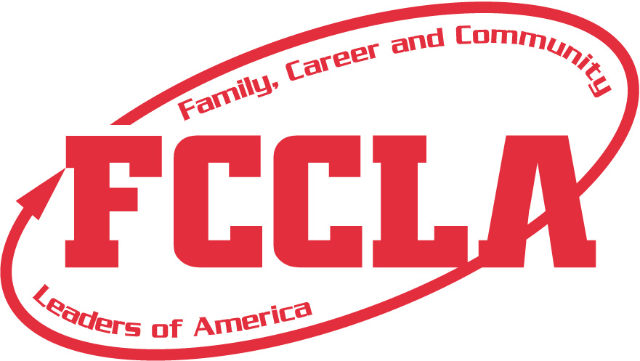
SOUTH DAKOTA FCCLA
2024-2025 Student Medical Release Form

Name of Student __________________________________________ Date of Birth __________________ Cell Phone____________________
Home Address ____________________________________________ Food Allergies/Physical Restrictions ______________________________
Name of School______________________________ Adviser _____________________ Adviser Cell Phone _______________________________
Name of Parent(s)_____________________________________________Parent Cell Phone(s) __________________________________________
Medical Information
Health Insurance Company Name __________________________________________ Policy Number ___________________________________
Policy Holder’s Name _______________________ Known allergies (drug or natural) _____________________ Date last tetanus shot ___________

Medication being taken ___________________________ History of heart condition/diabetes/asthma/epilepsy/rheumatic fever _________________
Other conditions _________________________________ Family Doctor _______________________________ Phone _______________________
I, the parent/guardian do hereby grant permission and certify that the above named student has my permission to attend the 2024-2025 local, region, and state conferences hosted by South Dakota FCCLA and national conferences hosted by the National Association. It is understood that members must adhere to the guidelines and protocol as set forth by each individual FCCLA event.
Liability Release
I hereby hold harmless and waive and release any liability claims or causes of action against National FCCLA, its directors, officers, employees, FCCLA school officials and chapter advisers, FCCLA state association and staff, and members in attendance, which my son/daughter or I may now or hereafter have arising in connection with my child’s travel, attendance, and participation, including, without limitation, claims for personal injury, bodily harm, illness, and disease (including without limitation, risk of death), and pertaining to causes including the current, potentially lethal COVID-19 virus for which there is as yet no known or available cure.
In the event of an emergency, I do voluntarily authorize medical services to be administered and/or obtained for the above named student as deemed necessary in medical judgment and in accordance with the above confidential information. I authorize the chapter adviser or other chaperoning adult to secure the services of a physician or hospital in the event of my son/daughter’s accident or illness, and willingly incur and will provide payment for the costs. I understand that, when necessary, in the event of an emergent illness or injury, my child will be transported to a local medical facility at the choice of the emergency medical professionals who respond.
I also understand that should my son/daughter become ill with COVID-19, I must travel to meeting site to care for my teenager within 24 hours’ notice. Additionally, my son/daughter will show no signs of COVID-19 in the hours/days prior to traveling to Fall Leadership Conference-Oct. 6-7, 2024; Region Meeting, State Leadership Conference-April 27-29,2025; or National Leadership Conference-July 5-9, 2025 in Orlando, FL.

I understand that participation in workshops/activities that may involve physical activity presents certain risks and hazards, including, but not limited to: muscle strains and sprains, bruises, broken limbs, dehydrations, other serious medical problems, or even death and other ordinary risks associated with strenuous physical activity. I acknowledge I do not have a past or present medical condition that may be affected by participating in this any event that may involve physical activity. I understand my participation is at my sole risk, and I voluntarily assume full and complete responsibility for any injury or accident, which may occur to me or my property during or in connection to any physical activity event. In consideration of value received of the right to participate in any workshop/activity involving physical activity, I, _________________________for myself, my heirs and assigns, do hereby waive, release, and forever discharge SD FCCLA/FCCLA, Inc., and each of their parent companies, subsidiaries, and affiliates, and all of their respective officers, directors, shareholders, agents, employees, successors and assigns, and volunteers assisting with this event (herein after the “Release of Parties”) from all manners of action, causes of action, suits, debts, damages, claims, and liability of any type or kind whatsoever, including attorney’s fees, arising from or in connection with the above-described activity. Furthermore, I agree to hold harmless and indemnify the Released Parties from and against all liability, claims, suits, demands, damages, judgments, costs, and expenses (including reasonable attorney’s fees) to which any of the Released Parties may be subject by reason of any claim for any injury to or death of any person or persons, or for damage to property or otherwise arising from or in connection with the above-described activity.

I have read this release of liability and assumption of risk agreement, fully understand its terms, understand that I have given up substantial rights by signing it, and sign it freely and voluntarily without any inducement.
___________________________________ _____________________________________ ________________________________
Parent/Guardian/Adviser Signature Parent/Guardian/Adviser Printed Name Date Signed
(Circle One) (Circle One)
UNDERSTANDING OF RISK - I understand the seriousness of the risks involved in participating in this program, my personal responsibilities for adhering to rules and regulation, and accept them as a participant.

____________________________________ _____________________________________ ________________________________
Participant Signature Participant’s PRINTED Name Date Signed

_________________________________________________________________________________________________________________________
Print Full Residential Address/City/State

