
2022 SOUTH DAKOTA FCCLA
FALL LEADERSHIP CAMP
Who: New members, returning members, chapter
officers, potential officers, & advisers!
Select from one of the following -
- Rookie Training – new members
- Power Training – returning members
Patty Hendrickson-Professional Leadership Trainer
- State Leadership Team Training
- Teens As Teachers/National Program Training (Must have attended Rookie Or Power Training OR be HS Jr. or Sr.) If you are interested, please complete this application to be accepted into the Teens As Teachers program.)
- Advisers – new & returning
When: October 2-3, 2022 (5:00 pm – 3:00 pm)
Where: Crossroads Hotel & Convention Center-
Huron, SD. Reserve hotel rooms before
September 18, 2022, to receive $82.99
hotel rate.
Registration: $50/person (Includes 2 meals on Monday)
Registration Due: September 16, 2022
Hotel Reservations: Reserve Today
Submit Registration/Payment to: SD FCCLA
Attn: Kris Brockhoft
Box 507, Wenona 103, SDSU
Brookings, SD 57007

2022-2023 SD FCCLA Theme:
Be INCREDIBLE! BE EMPOWERED!
FCCLA provides Incredible opportunities
to members and advisers through
FCS education. Exploring career opportunities, while instilling real-world skills, advocacy, and service in FCCLA members will guide them for the rest of their lives because FCCLA is IncREDible.



Region STAR Events: Members may compete in Professional Presentation at the Region Level for the 2022-2023 FCCLA year. Participants receiving gold medals advance on to compete at the State Leadership Conference in April.

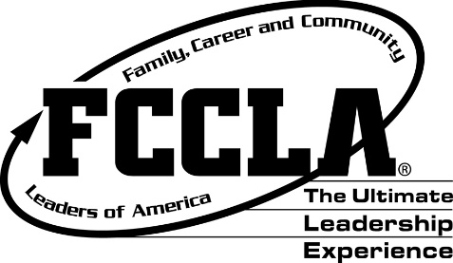
IMPORTANT DATES:
Fall Leadership: October 2-3, 2022, Huron Crossroads Convention Center (Registration Deadline-Sept. 16)
Capitol Leadership: October 10-12, 2022, Washington, D.C.
National Fall Conference: November 11-13, 2022, Columbus, OH
Region Meetings: See calendar updates posted on www.sdfccla.org
FCCLA Week: February 13-17, 2023 (See website ideas to celebrate each day.)
State FCCLA Leadership Conference: April 23-25, 2023 (Ramkota Convention Center)
National Leadership Conference-Washington, D.C.: July 2-6, 2023
www.fcclainc.org www.sdfccla.org

- Plan to attend Fall Leadership Weekend
- Apply for stipend to attend Capitol Leadership
- Affiliate online by November 1 to receive Teen Times, the Fast FACTS Newsletter, The Adviser and other important mailings and have access to FCCLA resources in FCCLA portal.
- Membership Dues: $8.00 State - $9.00 National
- Plan to compete in On-line Competitive Events
- Recruit your Knowledge Bowl team for Region Competition



