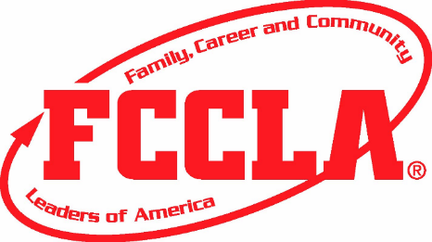 | South Dakota FCCLA  2017-2018  Most Outstanding Jr. High Member Award

South Dakota FCCLA is offering a recognition award inclusive to junior high members. The junior high members are the future of this organization, so it is important for junior high members to get involved. The future members of FCCLA must learn leadership skills early on to help build the organization. This year South Dakota FCCLA would like to encourage middle school/junior high members to apply for the Jr. High Member Award. All applicants receiving a gold level award will receive a certificate and state recognition. The highest ranking essay will receive an additional certificate and recognition at the State Leadership Conference.

Gold: | 1. National affiliation by December 1, 2017.  2. Complete two Course Work  3. Complete one Meeting Participation listed below.  4. Complete three Activities Lead listed below.  5. Complete one Chapter Meetings listed below.  6. Complete two Membership Recruitments listed below.  7. Included Letter of Recommendation from your adviser  highlighting your leadership skills.
Silver: | 1. National affiliation by December 1, 2017.  2. Complete two Course Work or one Meeting Participation listed below.  3. Complete two Activities Lead listed below.  4. Complete one Chapter Meetings listed below.  5. Complete one Membership Recruitments listed below.
Bronze: | 1. Chapter, State, and National affiliation by December 1, 2017.  2. Complete one Course Work or one Meeting Participation listed below.  3. Complete one Activities Lead listed below.  4. Complete one Chapter Meetings listed below.  5. Complete one Membership Recruitment listed below.
Numbers 1-19 | Titles | Supporting Evidence
1. | Affiliation | Affiliate chapter-submit copy of affiliation
2. | Course Work | Complete STEP One- submit a copy of certificate
3. | Course Work | Complete Power of One- submit evidence with adviser sign off
4. | Meeting Participation | Attend the 2017 Fall Leadership Training- submit a copy of registration
5. | Meeting Participation | Attend your Region's 2017-2018 Region Meeting- submit a copy of registration
6. | Meeting Participation | Attend the 2017 State Leadership Conference- submit a copy of registration
7. | Meeting Participation | Attend 2017 National Leadership Conference- submit a copy of registration
8. | Activities Lead | Lead a chapter activity- attach a summary and include pictures
9. | Activities Lead | Completed a STAR event at your Region Meeting
10. | Activities Lead | Completed one of the National Program Projects
11. | Chapter Meetings | Attend at least 2 chapter meetings- need adviser’s sign off and date of proof
12. | Membership Recruitment | Recruit members to be part of your FCCLA chapter- must have a member sign off
13. | Membership Recruitment | Recruit two members to attend a FCCLA chapter meeting- must have member attendees and adviser sign off
14. | Short essay | Write a short essay (100 to 200 words) explaining how FCCLA inspires you.

Place documentation in numerical order from 1-22 with the title and supporting evidence on the same page or together. Please save the application and documentation to a jump drive or develop a portfolio and mail by Wednesday, March 1, 2018 to:
Alcester Hudson FCCLA
Attn: Janelle Dickau
102 E 5th St.
Alcester, SD 57001

