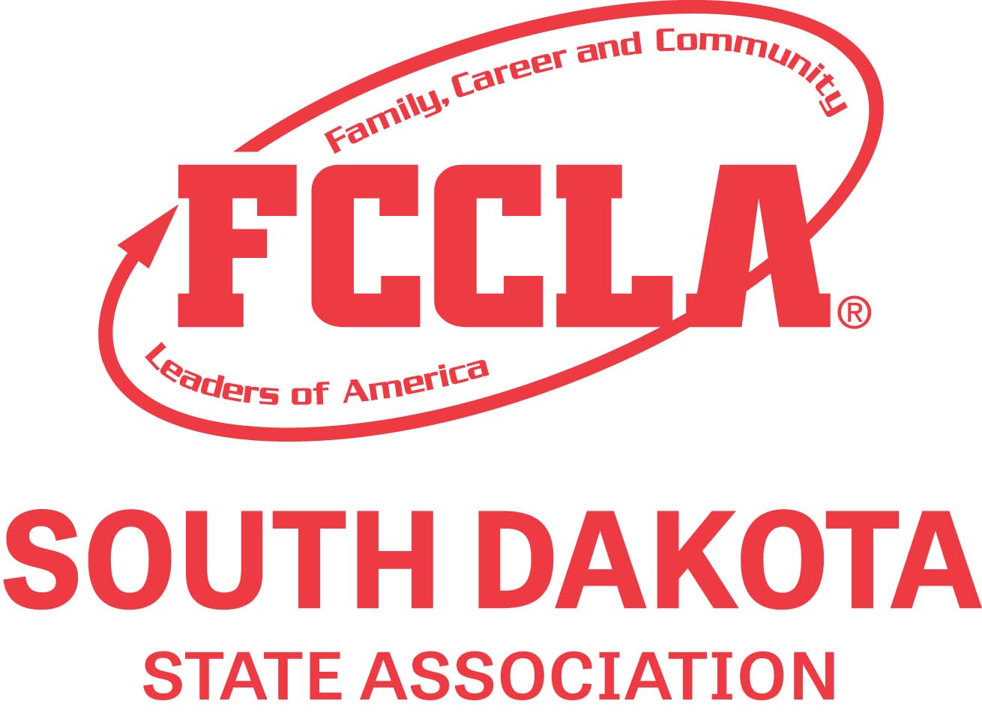
South Dakota FCCLA State Chapter Adviser Application
Due Friday, March 17th, 2024

Thank you for your interest in serving as the 2024-2025 SD FCCLA State Chapter Adviser.
This is a leadership position that allows you to help develop some of South Dakota’s finest
FCCLA leaders across the state. This position is identified in our bylaws as the liaison between
the past and present State Executive Councils. State Chapter adviser shall be an FCS teacher
and is highly recommended that State Chapter Adviser have previous experience as a state
officer adviser.

Please print completed application to PDF and email to the state office at Kristine.Brockhoft@lakeareatech.edu.

All applications are confidential. The final decision on selection of the state chapter adviser
will be made by the SD FCCLA Board of Directors’ Executive Committee. The candidate chosen
for this position will be notified two weeks prior to state meeting so they may make the necessary arrangements to extend their SLC stay one day (through Wednesday noon).

Compensation for duties performed includes:
  - State chapter adviser stipend – $3,000.00 – first half paid June 1, and second
half paid at the conclusion of the state chapter adviser responsibilities at the
2025 SLC conference after year-end report has been submitted to state adviser.
  - Stipend from Advisers in Action* (Amount to be determined and voted on at
the Advisers in Action business meeting yearly at SLC.)
  - State Chapter Adviser will submit receipts for reimbursement of supplies necessary to assist state officers in carrying duties out during the year.
  - Complimentary state meeting registration and hotel room (host state officer/officer candidate Sunday night reception/meetings to practice script/Monday supper);
Saturday night supper; Sunday complimentary hotel breakfast, lunch, and supper;
Monday complimentary hotel breakfast, lunch, and pizza for supper;
Tuesday hotel complimentary breakfast and lunch; and Wednesday hotel complimentary breakfast – Ramkota Sioux Falls.
  - Complimentary fall leadership weekend registration (includes 2 meals) and hotel room – Crossroad’s Hotel, Huron.
  - Complimentary adviser shared hotel room, hotel complimentary breakfasts, one lunch and one etiquette dinner at February Executive Council Meeting/Capital City Experience (Legislative Shadowing)-Pierre

SD FCCLA State Chapter Adviser Job Description:

- The State Chapter Adviser works directly under the guidance of the State Adviser. The State Adviser decision will be final on matters concerning state officers.
- State Chapter Adviser position starts at the State Leadership Conference.
  - State Chapter Adviser must be in attendance at this meeting.
  - New State Chapter adviser will attend designated office selection for the incoming Executive Council.
  - Attend meetings of the newly installed State Executive Council following the state meeting. [Required attendance on Tuesday (afternoon/evening) and Wednesday morning immediately following state meeting.]
  - Work with team-team building activities/goal setting, reservation for Tuesday evening supper, officer uniforms, national leadership responsibilities/arrival-departure-rooming together/state officer events/brainstorm 3 state meeting agenda ideas; 2024-2025 yearly theme/fall leadership workshop responsibilities, etc.
- Travel to National Leadership Conference with the Executive Council and take responsibility for students at that meeting. This travel is required for all State Chapter Advisers.
a. Work with State Executive Council and State Adviser to plan officer schedules for National
Leadership Conference.
  - Guide students as they become a team (communication, social media, decision making, projecting a positive image, etc.)
  - Supervise officers in day-to-day duties (Officer responsibilities include displaying state flag and leading state in cheers at general sessions, carrying out motivational activities for state delegation, planning and conducting state meetings and STAR Event awards recognition session for the SD delegation, etc.)
  - State Executive Council curfew checks – if sharing hotel rooms in same hotel as state chapter adviser – virtual check if located in another hotel.
  - Plan group evening meal or other activity for state officers & advisers at National Leadership Conference.
- Responsibilities during the year:
  - Assist State Adviser in planning leadership development opportunities for state officers.
  - Assist State Adviser in working with State Executive Council to define their roles, both as an officer team and in individual offices. This includes assisting in developing a program of work, setting goals, and creating a plan to reach those goals.
  - Work with State Executive Council throughout the year to fulfill the duties of their office.
  - Help officers with responsibilities to meet deadlines throughout the year, such as Fall Leadership (Rookie Camp workshop plans), CTSO Center Leadership Training Events, Capitol City Experience [Setting Legislative Shadow Appointments], CTSO State Officer Training, State Executive Council meetings, social media posts, etc.
  - Possible assistance at Region Meetings could be needed if State Adviser is unable to attend all meetings due to conflicting schedules.
  - Be present at August/September Executive Council Meeting, Fall Leadership-Rookie Training, January Winter Leadership Training Executive Council Meeting, February Legislative Shadowing/CTSO Capital City Experience/Executive Council Meeting.

- State Leadership Meeting
  - Assist officers in planning state leadership conference (script ideas, stage decorations, costumes, props, new officer installation, etc.) and organizing materials needed.
  - Attend pre-conference virtual script practice with script writer/state officers. Practice script with officers at state leadership conference.
  - Work with State Executive Council from Saturday (1:00 PM) to (Tuesday after cleanup of final general session) ensure a successful state leadership conference.
  - State officer curfew check.
  - Plan and oversee new state officer selection activities, work with interview team, and allow incoming state chapter adviser to observe activities where allowed.
  - Assist with New/Current State Officer Reception Sunday night at SLC after general session – hosted in State Chapter Adviser suite.
  - Order pizza for delivery for state officer supper on Monday night at SLC.
- End of Year Reporting
  - At the conclusion of the FCCLA year of activities, State Chapter Adviser will be responsible for reporting to the State FCCLA Adviser by turning in report (binder) that includes a detailed list of responsibilities completed (per event); handouts/worksheets used at planning meetings, workshops, trainings; NLC state meeting scripts; report form that includes all social media addresses/passwords/codes, photograph accounts; correspondence/ activities/onsite schedule used to coordinate officer selection at 2025 SLC; include list of team contact information for the year in binder along with seating rotation and other forms used throughout the year. Include planning forms, workshop lessons, and handouts for fall leadership along with final schedule and duties of each officer.

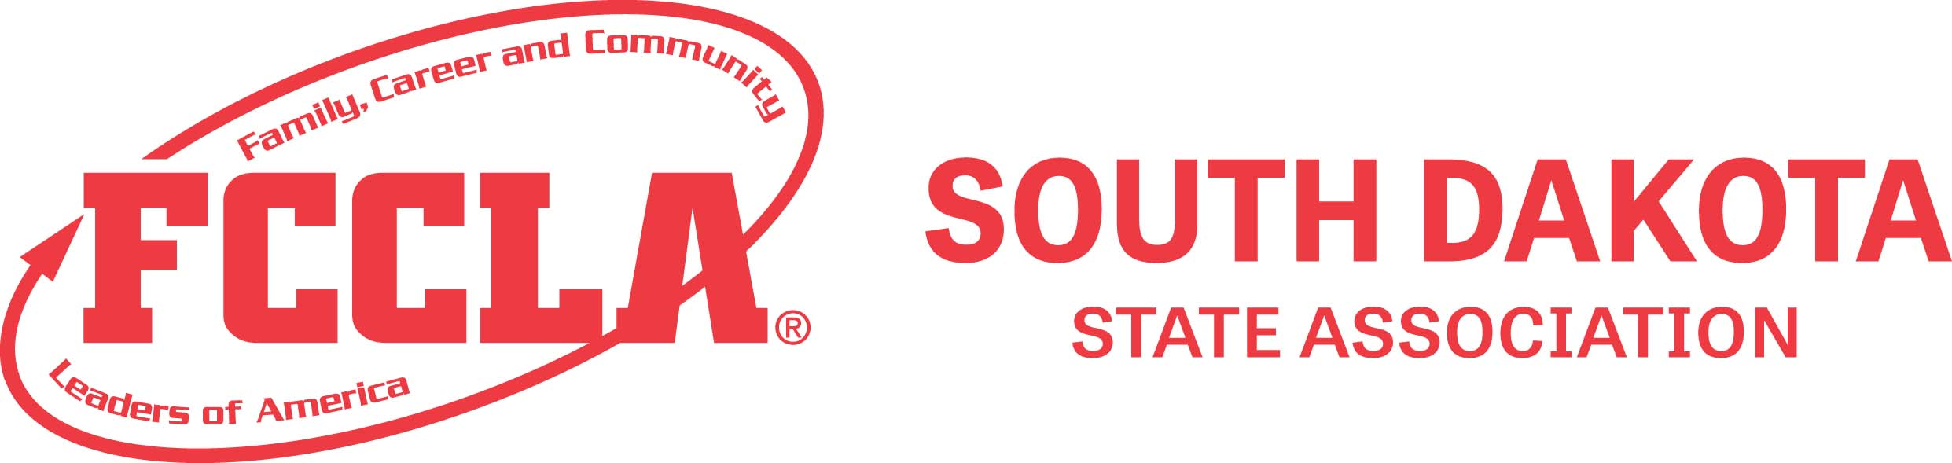
South Dakota FCCLA State Chapter Adviser Application

Name: ___________________________________________________________

School or Current Position: _________________________________________

School Phone Number: _____________________Cell Phone Number:____________________

State FCCLA Experience:
- State Officers (s), officer position:

- Region Officers:

- Leadership Team Members:

Have you previously served as the State Chapter Adviser? Year(s):

Have you previously had any other leadership positions in FCCLA?

What talents and skills do you feel you could contribute to the role of State FCCLA Chapter Adviser?

Why would you like to serve as the State Chapter Adviser?

Please state your thoughts on what you think the main objectives for this position should be:

Please return via email by March17th to: Kristine.Brockhoft@lakeareatech.edu
State Adviser, SD FCCLA, 103 Wenona Hall, Box 507, SDSU, Brookings, SD 57007.

