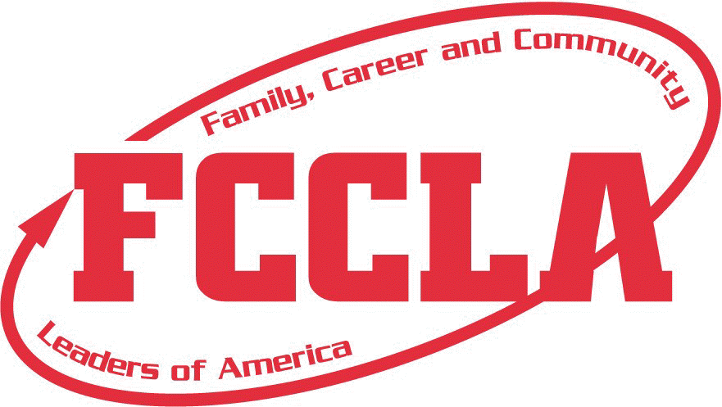
SD FCCLA CURRENT TRENDS TEAM
FOCUS PROGRAMS & PROJECTS 2017-2018
The SD FCCLA Current Trends Leadership Team has chosen the national programs, Stop the Violence, FACTS and Student Body, as the foundation for Current Trends for the 2017-2018 school year. The theme is “Destination: Safety” and focuses on the concerns of Physical Safety, Mental Safety, and Driving Safety for teenagers and their families. Some current trends addressed in these areas include:
- Self-Respect and respect for others
- Protecting yourself from harassment and bullying
- Protecting yourself from dating violence
- Preventing teen pregnancy
- Stopping drinking and driving.
We are asking SD FCCLA chapters to create projects about these programs and areas of concern to promote the issues and serve the communities in our state. Here are some ways for your chapter to Motivate, Educate and Serve!
MOTIVATE:
- Facts about self-respect and respect for others, bullying, distracted driving, dating violence, teen pregnancy, etc. hung on lockers or handed out with tickets at sporting events
- School announcements with statistics/information about bullying, dating violence, self-respect and respect for others, distracted driving, teen pregnancy etc.
- Infographics with current statistics and information about Current Trends concerns published in local and school newspapers, handed out at community events, etc.
- Facts about Current Trends concerns on water bottles/milk cartons at lunch
- Flyers in sports programs or at grocery stores and other local businesses with information about these concerns
- Stickers about drunk driving that people can stick into cars
- Keychains with the Current Trends campaign theme—“Destination Safety” (something that can spark interest and spread the message)
- ID holders with the Current Trends campaign message on them
- Wristbands distributed during sports events (one possible source for reasonably priced wristbands is wristbandcreations.com)

EDUCATE:
- “Destination—Safety” Week (sample title): days with activities, speakers, etc. on the topics of concern:
- Self-Respect/Respect Others (speakers, self-defense, yoga demonstration, post-it notes with positive sayings)
- Teen pregnancy speaker
- Panel discussion for middle or high school students that were impacted by unsafe behaviors
- Dating violence abuse survivor speaker
- Down with Distracted Driving Week (drunk googles obstacle course; speakers, pledge not to drive distracted, etc.)
- Mental health/suicide awareness speaker
- Workshop/panel discussion to highlight the role and importance of self-respect and respect for others
- Mock Accident (SD Highway Patrol has resources to help set this up)
- Resource speaker on distracted/impaired driving
- Survey about drinking and driving
- “Why I Matter” or “I Matter/You Matter” campaigns

ADVOCATE
- Blanket toss (people toss money into a blanket at a basketball/volleyball game)--donations to an organization related to the areas of concern (NAMI, MADD, SADD, ADAA, etc.)
- Local hospitals/clinics/shelters--financial support through selling items with an information tag/sticker to raise awareness of issues
- Suppers: Soup/Sandwich, Baked Potato, Ethnic Foods, etc.
- Collecting donations at a local supermarket, bank, etc. to raise money for donations to local shelters
- Selling a product for the cause of donations to relevant organizations/shelters

*The Leadership Teams will be available at ALL Region meetings, advocating for their concerns and providing information about the team’s topics. The state awards for Current Trends Team projects will be awarded in tiers—Gold (3 projects, 1 from each area); Silver (2 projects, 1 from 2 areas) Bronze (1 project from 1 area); 1 project. If you have any questions, contact Mrs. Jean Clarke at jean.clarke@k12.sd.us or call 605-449-4336.

